EC CHM Project
EUNIS Database Tool .Net 2.0
- User Guide

Modification history
Date | Version | Author | Reason for modification
10 Dec. 2005 | 0.1 | D. Chirca (Finsiel) | First draft
10 Dec. 2005 | 2.0 | D. Chirca (Finsiel) | Second version, for EUNIS v2
Table of Contents
1 Introduction 4
1.1 Purpose of this document 4
1.2 Structure of this document 4
1.3 Field of application 4
1.4 Deviations from PMP 4
1.5 Reference and applicable documents 5
1.6 Terminology 5
1.6.1 Abbreviations, acronyms and definitions 5
1.6.2 Definitions 6
2 Content 7
2.1 Introduction 7
2.2 Technical information 8
2.3 Software installation 8
2.4 Hardware requirements 9
2.5 EUNIS Database Tool .NET usage 9
2.6 Functions 11
2.6.1 Options function 11
2.6.2 EUNIS objects to be loaded 12
2.6.3 Access database locations 13
2.6.4 MySQL database 14
2.6.5 Log file location 16
2.6.6 Error handling 16
2.6.7 Load EUNIS MySQL database 18
2.6.8 Clear/Create EUNIS MySQL database 18
2.6.9 Clear temporary data from EUNIS MySQL database 18
2.6.10 Create country statistics 19
2.6.11 Update Species references 19
2.6.12 Run tables diagnostic 19
2.6.13 System information 19
2.6.14 Recalculate sites coordinates 19
2.6.15 Set current classification of habitats 19
2.6.16 Populate SOUNDEX table 20
2.6.17 Show EUNIS MySQL table statistics 20
2.6.18 Show EUNIS MySQL Species/Habitats/Sites statistics 21
2.7 Specific operations 22
2.7.1 Preparing the MS Access database image of EUNIS 22
2.7.2 Updating the EUNIS MySQL Database 22
2.7.3 Backing up the tables in the EUNIS database. 23

Introduction

Purpose of this document
This document describes the EUNIS Database Tool .NET application (v2).

Structure of this document
See Table of Contents.

Field of application
Contract | CWU Title | CWU Code
502009.4 | Data flow and data management | WU3

The content of this document will support the extension of the EUNIS web application and related products.

Deviations from PMP
N/a.

Reference and applicable documents

Code | Title | DATE
CHM-DW5-PMP-001 | Project Management Plan | 19 Feb 2003
CHM-DW3-DNC-001 | WU3 Dataflow and data management – Work order | 12 Feb 2003
CHM-DW5-PMP-002 | Production plan | 16 Jan 2003
CHM-CW6-ADD-002 | EUNIS – Function and data analysis | 30 Oct 2000
CHM-CW6-ADD-002 | EUNIS functions and data analysis | 03 Jan 2001
CHM-BW4-DNC-002 | EUNIS – Species Data Base | 28 May 2001
CHM-BW2-CTN-007 | EUNIS – Species & Habitats data base | 13 Jun 2001
CHM-CW3-CNT-001 | EUNIS – Species & Habitats data base | 10 May 2002
CHM-DW3-CNT-001 | EUNIS data base with Sites | 03 Mar 2003

Terminology

Abbreviations, acronyms and definitions
EC | European Commission
EUNIS | European Nature Information System
ETC/NPB | European Topic Centre / Nature Protection and Biodiversity
EDTN | EUNIS Database Tool .NET (v2)
CHM | Clearing-House Mechanism
ROD | Reporting Obligations Database
MoE | Ministry of Environment
WU | Contractual Work Unit
EEA | European Environment Agency
EIONET | Environmental Information and Observation Network
IG | Interest Group (in CIRCA)
NFP | National Focal Point
SA1 | 1st Specific Agreement
SA2 | 2nd Specific Agreement
SA3 | 3rd Specific Agreement
SA4 | 4th Specific Agreement
PMP | Project Management Plan
N/a | Not applicable

Definitions
CIRCA or CIRCLE | The extranet tool developed under the IDA Programme and which constitutes the kernel of the EIONET system; CIRCLE is the name given to the tool in EIONET whereas CIRCA is the name of the tool to be used across Europe.
Interest Group | CIRCLE (i.e. CIRCA) is organised around Interest Groups i.e. a private workspace for a group of people that need to collaborate to achieve common objectives and tasks.
Interest Group Leader | In the context of CIRCLE, the Interest Group Leader is granted extended privileges to administrate, manage and customise the Interest Group. S/he defines users and grant access rights within the Interest Group.

Content

Introduction
EUNIS Database Tool .NET (EDTN) is an application for importing data from heterogeneous sources into the EUNIS MySQL database.
These sources are MS Access databases containing information on Species, Habitat types and Sites and other information related to EUNIS (Designations, lookup tables, countries information, languages etc.).
The EUNIS MySQL Database (EUNIS Database) is the database used by the EUNIS web application to retrieve and store data. The structure of this database is described in another document: EC CHM Project – EUNIS Database Structure.
For further references regarding MySQL, consider visiting www.mysql.org.
With EDTN users can:
- Specify the MS Access databases to be used for data import.
- Specify the MySQL database to be loaded.
- Specify logical blocks of data to be processed (Species, Habitats, Sites, References, Dictionaries etc.)
- Load the data and have a full log of the operations performed.
- Clear/Create the EUNIS MySQL database.
- Create a MS Access database image of the EUNIS MySQL database.
- Perform maintenance tasks on the EUNIS MySQL database (Update sites coordinates, set current habitat types classification etc).
- View statistics regarding the MySQL database.
- Create the DiGIR Provider data
One of the strongest facilities built into this application is the error handling module, which is very flexible and gives the users many choices of how to proceed further whenever an error occurs during data loading. Such error can occur when data logic is broken (string found when integer expected, duplicate data in source databases etc.) or when physical errors are encountered (not enough disk space etc).
Whenever new data is available to be added to EUNIS, this application should be used to create the EUNIS MySQL database.

In summary, EDTN uses a set of MS Access databases to create a single MySQL database to be used by the EUNIS web application.

Technical information
EDTN is an open source product developed by Finsiel Romania with:
- Microsoft .NET framework SDK 1.1, using the VB.NET language.
- NAnt (http://nant.sourceforge.net).
- Microsoft ADO 2.7 libraries.
- MySQL ODBC Data Connector 3.51 (http://www.mysql.org).
EDTN is a Windows application, featuring an easy to understand GUI interface. Functions are available through menus and toolbar buttons.

Here is a screenshot of the main window of the application:

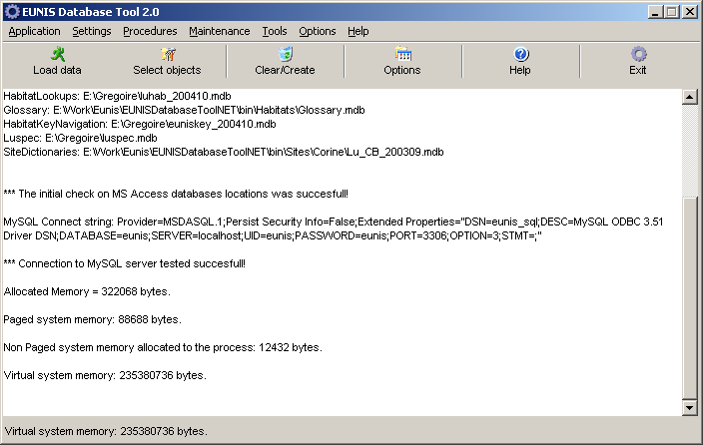

Software installation
EUNIS Database Tool .NET is provided as an application already installed on a dedicated machine hosted at the EEA agency in Copenhagen. Access to the application (from Bucharest, Copenhagen and Paris) is done in remote connection.

Software that must be installed on the machine:
- Microsoft .NET Framework 1.1
- MS Access 2000/2003
- MySQL ODBC Driver 3.51 or better
- MySQL Database Server 4.x or better installed with UTF-8 support and ISAM type tables
- EDTN 2.0
- MS Word 2000/2003 to have access to the User Guide documentation

Hardware requirements
The PC on which this application is installed and used should meet the following minimal requirements:

- OS: Windows 2000 or better (XP, 2003)
- 1,7 GHz processor or better
- 256 MB RAM or better
- 2 GB available free space

On such a machine, a full load of the EUNIS database will take about 2 days.

EUNIS Database Tool .NET usage
In order to create the EUNIS MySQL database with EDTN, the user should perform the followings steps (in this order):

1. Run EDTN (use the Desktop shortcut).
2. Select Options/Options from the menu or click the Options button in the toolbar. to customize the application behavior.
3. Select Settings/Access database location from the menu and specify the MS Access databases to be used as data input.
4. Select Settings/EUNIS MySQL database location from the menu and specify the MySQL database to be used as data output.
5. Select Procedures/Clear/Create EUNIS MySQL database from the menu or click the Clear EUNIS MySQL button from the toolbar. This procedure will prepare the EUNIS MySQL database by cleaning/creating all the required database structure, including indexes. For more information, see the functions section in this document.
6. Select Settings/EUNIS objects to be loaded and choose the data to be loaded.
7. Select Procedures/Load EUNIS MySQL database from the menu or click the Load data button from the toolbar. The loading procedures will start. At any time, the user can stop data loading clicking on the Stop operation button from the toolbar. After all the operations are completed, the user should choose Tools/View log from the menu to see the log of operations performed by the application. The log might contain warning and errors detected by the application. If the errors can’t be ignored, the source of errors should be corrected and the user should restart from the step 5.
8. Select Maintenance/Create countries statistics from the menu. This function will prepare some statistical data which needs to be stored in the database.
9. Select Maintenance/Recalculate sites coordinates from the menu. This function will verify/update the geographical coordinates of the sites.
10. Select Maintenance/Set current classification of Habitats from the menu. This function will let the user choose which habitats classification should be used as current.
11. Select Maintenance/Populate DiGIR data from the menu. This function is used to create the DiGIR Provider data.
12. Select Maintenance/Populate SOUNDEX table from the menu. This function is used to create the “phonetic like” search support table.
13. Select Maintenance/Update Species reference from the menu. This function is used to update species references data.
14. Select Maintenance/Create MS Access database copy… from the menu. This function will create a MS Access database image of the EUNIS MySQL database loaded in the previous steps.

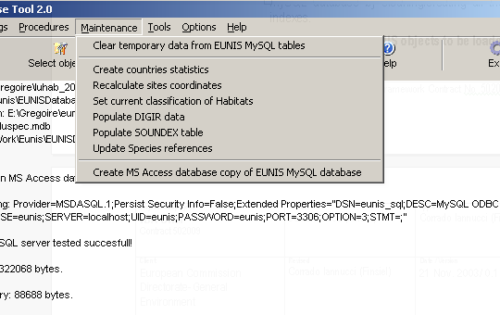

Detailed information on each function follows next in this document.

Functions
In the next sections, the main functions of the tool are described.

Options function
It can be accessed from Options/general options… menu.

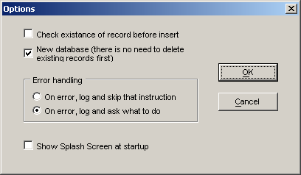

This function let the user:
- Decide how the tool will check/not check for duplicate rows in tables. If such a duplicate is detected and the option is selected, the log will contain a message about the duplicate found. Note: Due to the fact that MS Access data sources contain duplicates, it is NOT advisable to select this option.
- Specify that the EUNIS database is created from scratch, and there is no need to delete first the existing records. Normally, EUNIS is loaded completely from scratch every time, so this option should be checked because it speeds up the operations.
- The error handling panel gives the users the opportunity to choose how the errors should be treated. The recommended option is to ask the user what to do. If this option is selected, whenever an error occurs, a window is displayed on the screen and the user can choose how to proceed. The error window will present a description of the error and will give the users the following options: Retry, Skip instruction, Skip whole function, Always skip on errors and Exit (End) application execution. All errors are also logged on the screen in the main window and in the error log.
- If the splash screen will pop up when the application is started.

EUNIS objects to be loaded
The database loading procedures are divided in smaller steps, so that the user can choose to load the database in steps.

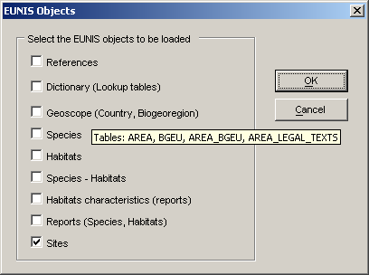

This window let the user choose what data should be imported into EUNIS. Normally, when the EUNIS database is created, all options should be checked.
However, sometimes the database is created in small steps. This is when is convenient to proceed data loading object by object.

Note: If you don’t select all objects, the order is crucial! You can’t load species if you have not loaded first the references. The correct order is from top to bottom – from References to Sites.

Access database locations

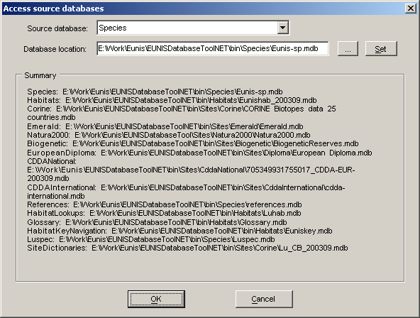

This function let the user specify the location of the MS Access source databases.
For each entry in the combo list named ‘Source database’, user must:
- Click the “…” button
- Select the correct Access database
- Click the “Set”’ button.

The “Summary” panel gives an overview of all the MS Access data sources selected.

MySQL database

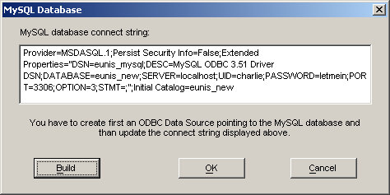

This is where you select the MySQL database to be used for data loading and define the connection string for that database.
In order to do this, the following steps should be done first:
1. Install MySQL, version 4 or greater
2. Create a new MySQL database, named “eunis”, for example.
3. Modify the mysql.ini configuration file to contain the following entries:

set-variable=key_buffer=48M
set-variable=lower_case_table_names=0
set-variable=bulk_insert_buffer_size=64000000
set-variable=sort_buffer=4M
set-variable=read_buffer_size=1M
set-variable = max_allowed_packet=10M

4. Create a EUNIS user for the new database which has rights to SELECT, INSERT, UPDATE, DELETE.
5. Install the MySQL ODBC connector.
6. Create in Windows a new ODBC data source which points to the MySQL EUNIS database – for example, “eunis”
Change in the above window the connection string. If you don’t know how to do this, press the ‘Build’ button and a wizard will be displayed:

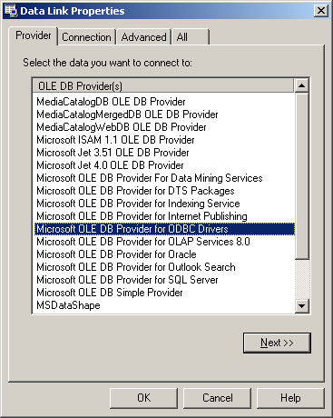

7. In this wizard, you must choose in the first window ‘Microsoft OLE DB Provider for ODBC drivers’ and click ‘Next’. In the next window, you must choose the ODBC data source you have created at step 6 and enter the username and the password you have created at step 4. Than, you can click ‘Test connection’ to test that everything went OK.

Log file location

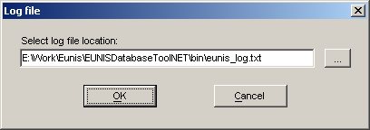

This function let the user specify where the log of operation should be created.
The log can be seen (after you have finished loading the data) through the menu Tools/View log.

Error handling

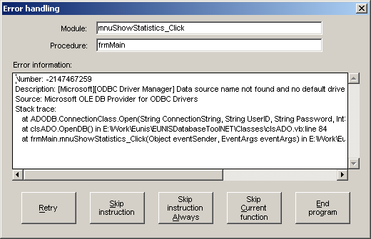

If an error occurs during a procedure, the above window is displayed and the user can choose how to proceed further. The window shows the user:
- The module which is the source of error
- The function which is the source of error
- Exact details about the source of error

Retry: If this button is clicked, the application will retry the instruction which was the source of error. This is useful in 2 cases:
- When the error occurred due to a non repeatable event (connection timeout etc.)
- When the user can correct the source of the error, without stopping the data loading operations

Skip instruction: If this button is clicked, the application will skip the instruction which was the source of error. This is useful when the error occurred due to a rare event (some data in the source contains broken information or logic, but the other data is good, so we should skip only that data/row from loading into EUNIS)

Skip instruction always: If this button is clicked, whenever another error occurs in the application, the above will be no longer displayed and the program will automatically skip the instruction which was the source of error. The future errors will not be logged. This is useful when there are lots of errors and there is no point in dealing with each one. This can happen, for example, when there are lots of duplicates in the data source and the user has not selected in the ‘Options’ window to not check for duplicates.

Skip current function: If this button is clicked, the application will skip the entire current function which was the source of error.

The application is organized in modules, each module having a number of functions. For example, the Geoscope module has functions to: load countries, load biogeoregion and load the relation between countries and biogeoregion. This option is useful when the data is broken for one specific function (for example, the Countries table is corrupt) and the user wants to skip all country data from loading.

End program: If this button is clicked, the application will stop. This is useful when a major error occurred and has no sense to continue execution.

Note: The EUNIS database contains many relations between object. These relations are resolved at runtime using both data sources and both EUNIS data. It is highly recommended to always proceed with a full database reload.

Load EUNIS MySQL database

When the user selects this option from the menu, the data loading procedures will start. In the main screen and the status bar, runtime execution information will be displayed:
- the number of records found in source tables
- the number of records inserted
- the current tables used
- the current module in execution
- other information

Note: This function should be executed after the application has been configured properly (the source databases have been selected, the MySQL destination database has been selected and that database has been cleared / created – see next function)

Clear/Create EUNIS MySQL database
When the user selects this option from the menu, the EUNIS database structure is created. This means:
- creating the EUNIS tables
- insert static data in some of the tables
- creating the indexes
If the user chooses this function, it will be prompted if also the auxiliary tables should be cleared. These tables refer to:
- Users and roles
- Web Content management tables
- Temporary data
When the EUNIS is created for the first time, the user should choose ‘Yes’. Otherwise the user should choose ‘No’, to avoid loosing the text modified and the users modified in the mean tine.
The auxiliary tables should not be copied to the “official” database.

Clear temporary data from EUNIS MySQL database
This function clears the temporary data from the EUNIS database. The same functionality can be achieved by a user with Administrator rights, online, through the Services page of EUNIS web application.

Create country statistics
This function creates countries statistics. It must be executed after all the loading operations have been completed.

Update Species references
The Species references function is about populating the tables used at runtime by the web application to display the tab structure on the pages.

Run tables diagnostic
This functions uses the ANALYSE MySQL built in function to analyze the integrity of the database

System information
This function will display a window containing system information related to the machine where the tool is installed.
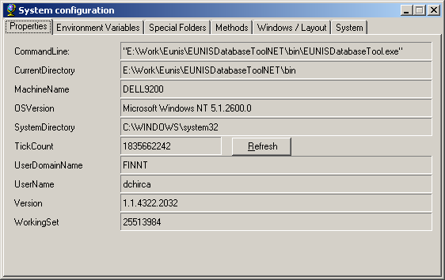

Recalculate sites coordinates
This function updates the sites coordinates in the EUNIS database. It must be executed after all the loading operations have been completed.

Set current classification of habitats
This function allows the user to specify what is the current classification of habitat types.

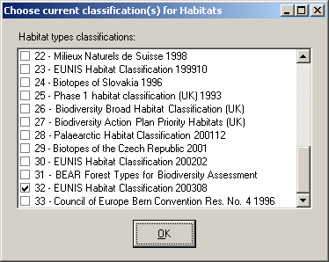

Note: Only one classification should be selected as current!

Populate SOUNDEX table
This function will load the corresponding “soundex” table used online for searches.

Show EUNIS MySQL table statistics
This function should be used to see how many rows were inserted in the EUNIS database.
The results are displayed in the main window.
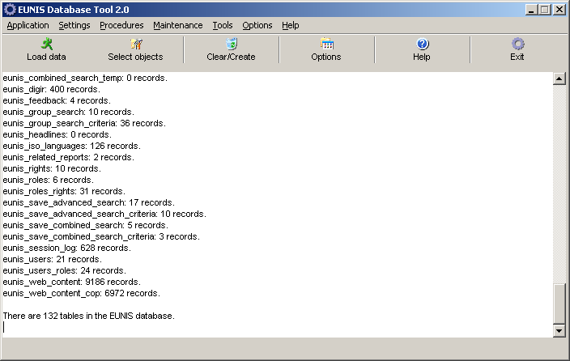

Show EUNIS MySQL Species/Habitats/Sites statistics

This function should be used to see how many nature objects of every kind were inserted in the EUNIS database and also to check the number of relations between them existing in EUNIS.

The results are displayed in the main window.
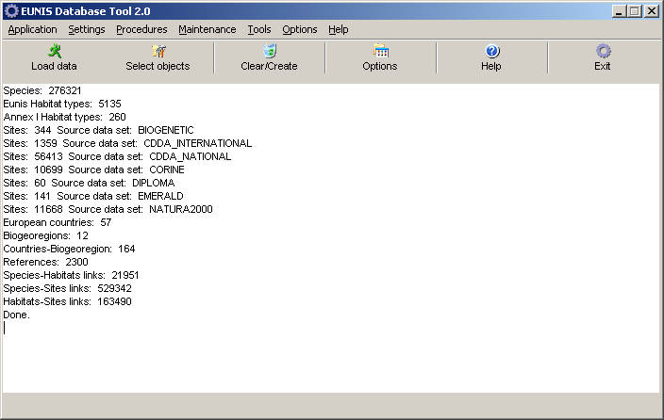

Specific operations

Preparing the MS Access database image of EUNIS
The EUNIS web application gives the registered user the possibility to download a copy of the EUNIS MySQL database in MS Access format. This function is available in Services page, accessible from the home page of EUNIS, after the user has logged on.
In order to provide such a function, first we need to prepare the MS Access database (of course, after all data loading has been completed successfully). This is done with EDTN, using the menu Maintenance/Create MS Access copy of EUNIS MySQL database.
When the user accesses this function, a window will appear on the screen, asking for the username and the password of a MySQL user who have enough rights to perform data export and also the MySQL database name to be exported (“eunis”, typically).

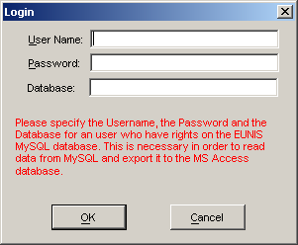

Pressing the ‘OK’ button will create the MS Access database. At the end of the operation, the user will be informed about the mdb file created. This file will be created in the application folder, with the name “eunis_xxx”, where “xxx” denotes the current date.
Note: This operation will take some minutes.

The created files must be copied to the EUNIS folder, under Tomcat. Details on how to do this can be found in the document: EC CHM Project – EUNIS Web Application – Administration Guide.

Updating the EUNIS MySQL Database
After the EDTN was used to create a new/updated version of the EUNIS MySQL Database, the following operations should be executed:
1. Prepare an archive (zipped) with the tables that will be moved to the official database. By official database we mean the database actually used by the online application. This is done by simply copying and archiving the files found in MySQL data folder (the operation should be executed by a system administrator and does not normally require stopping the MySQL service). What should be copied? If it’s a new installation the answer is: all tables. If it’s a data update, the archive will contain only the tables that have their names starting with the prefix “CHM62EDT_” and “”DC_” only. If a “Populate DiGIR” function was executed, the archive will also contain the table “EUNIS_DIGIR”. This archive will be used to overwrite the official database files.

Backing up the tables in the EUNIS database.
Sometimes, when EUNIS database is loaded, it is necessary to save some data existing already in the old version of database.
This kind of data refers to:
- Users data (tables EUNIS_USERS, EUNIS_ROLES, EUNIS_USERS_ROLES)
- Web content management data (tables EUNIS_WEB_CONTENT)
- Users feedback (tables EUNIS_FEEDBACK)
- Glossary terms (tables CHM62EDT_GLOSSARY)
- Users saved criteria, for the tables:
  - EUNIS_GROUP_SEARCH,
  - EUNIS_GROUP_SEARCH_CRITERIA,
  - EUNIS_SAVE_ADVANCED_SEARCH,
  - EUNIS_SAVE_ADVANCED_SEARCH_CRITERIA,
  - EUNIS_SAVE_COMBINED_SEARCH,
  - EUNIS_SAVE_COMBINED_SEARCH_CRITERIA).

In order to save this data, the user should perform the following steps:

1. Backup the above mentioned tables. In MySQL, this means simply making a backup copy of all files for who matches the above names from the folder where EUNIS MySQL data is located.
2. Perform a reload of the EUNIS database (Clean/Clear database than Load data)
3. Restore the backup copies (simply overwrite the files created by EDTN) to the eunis database.

Note: Steps 1 and 3 require that MySQL server service is stopped.

